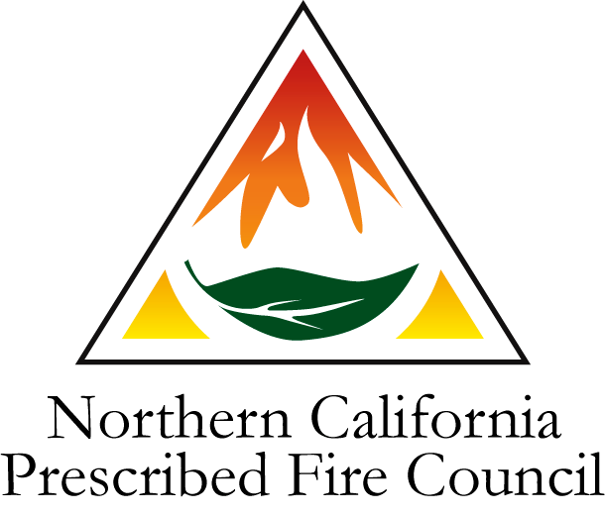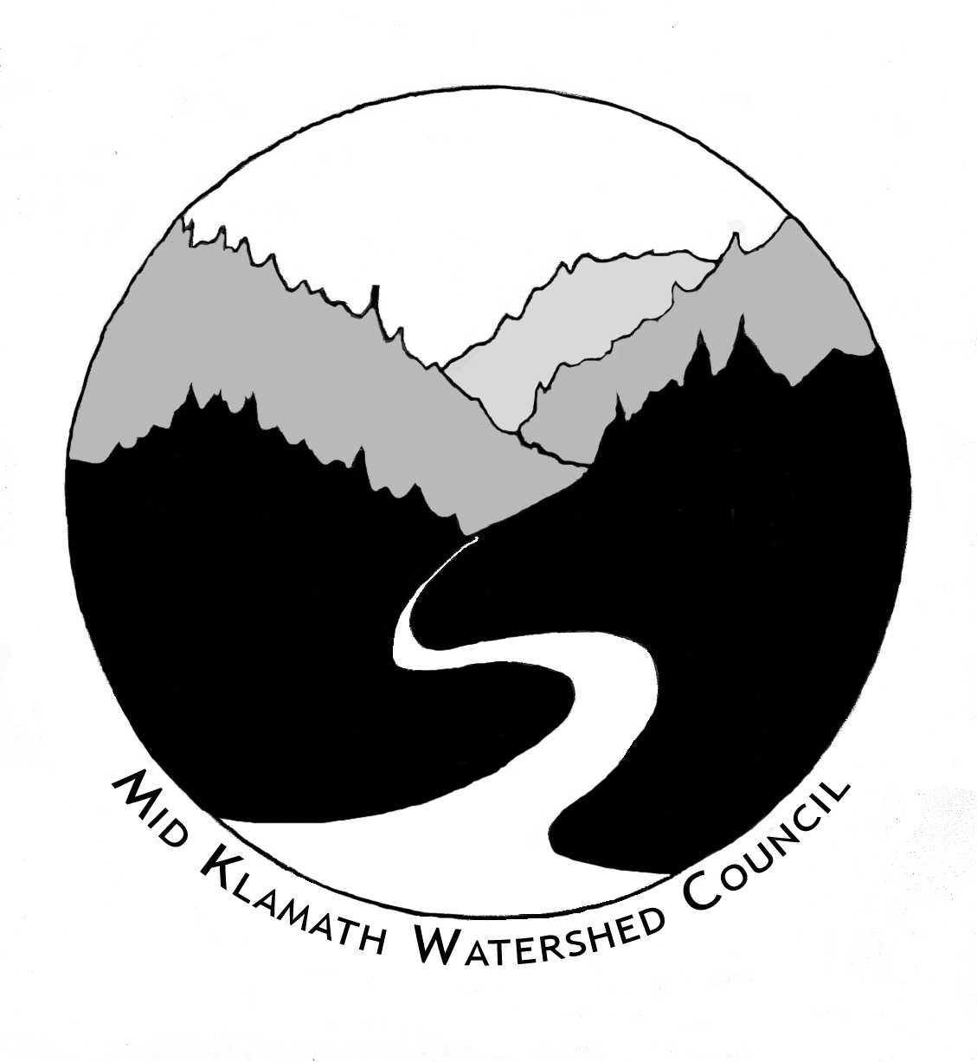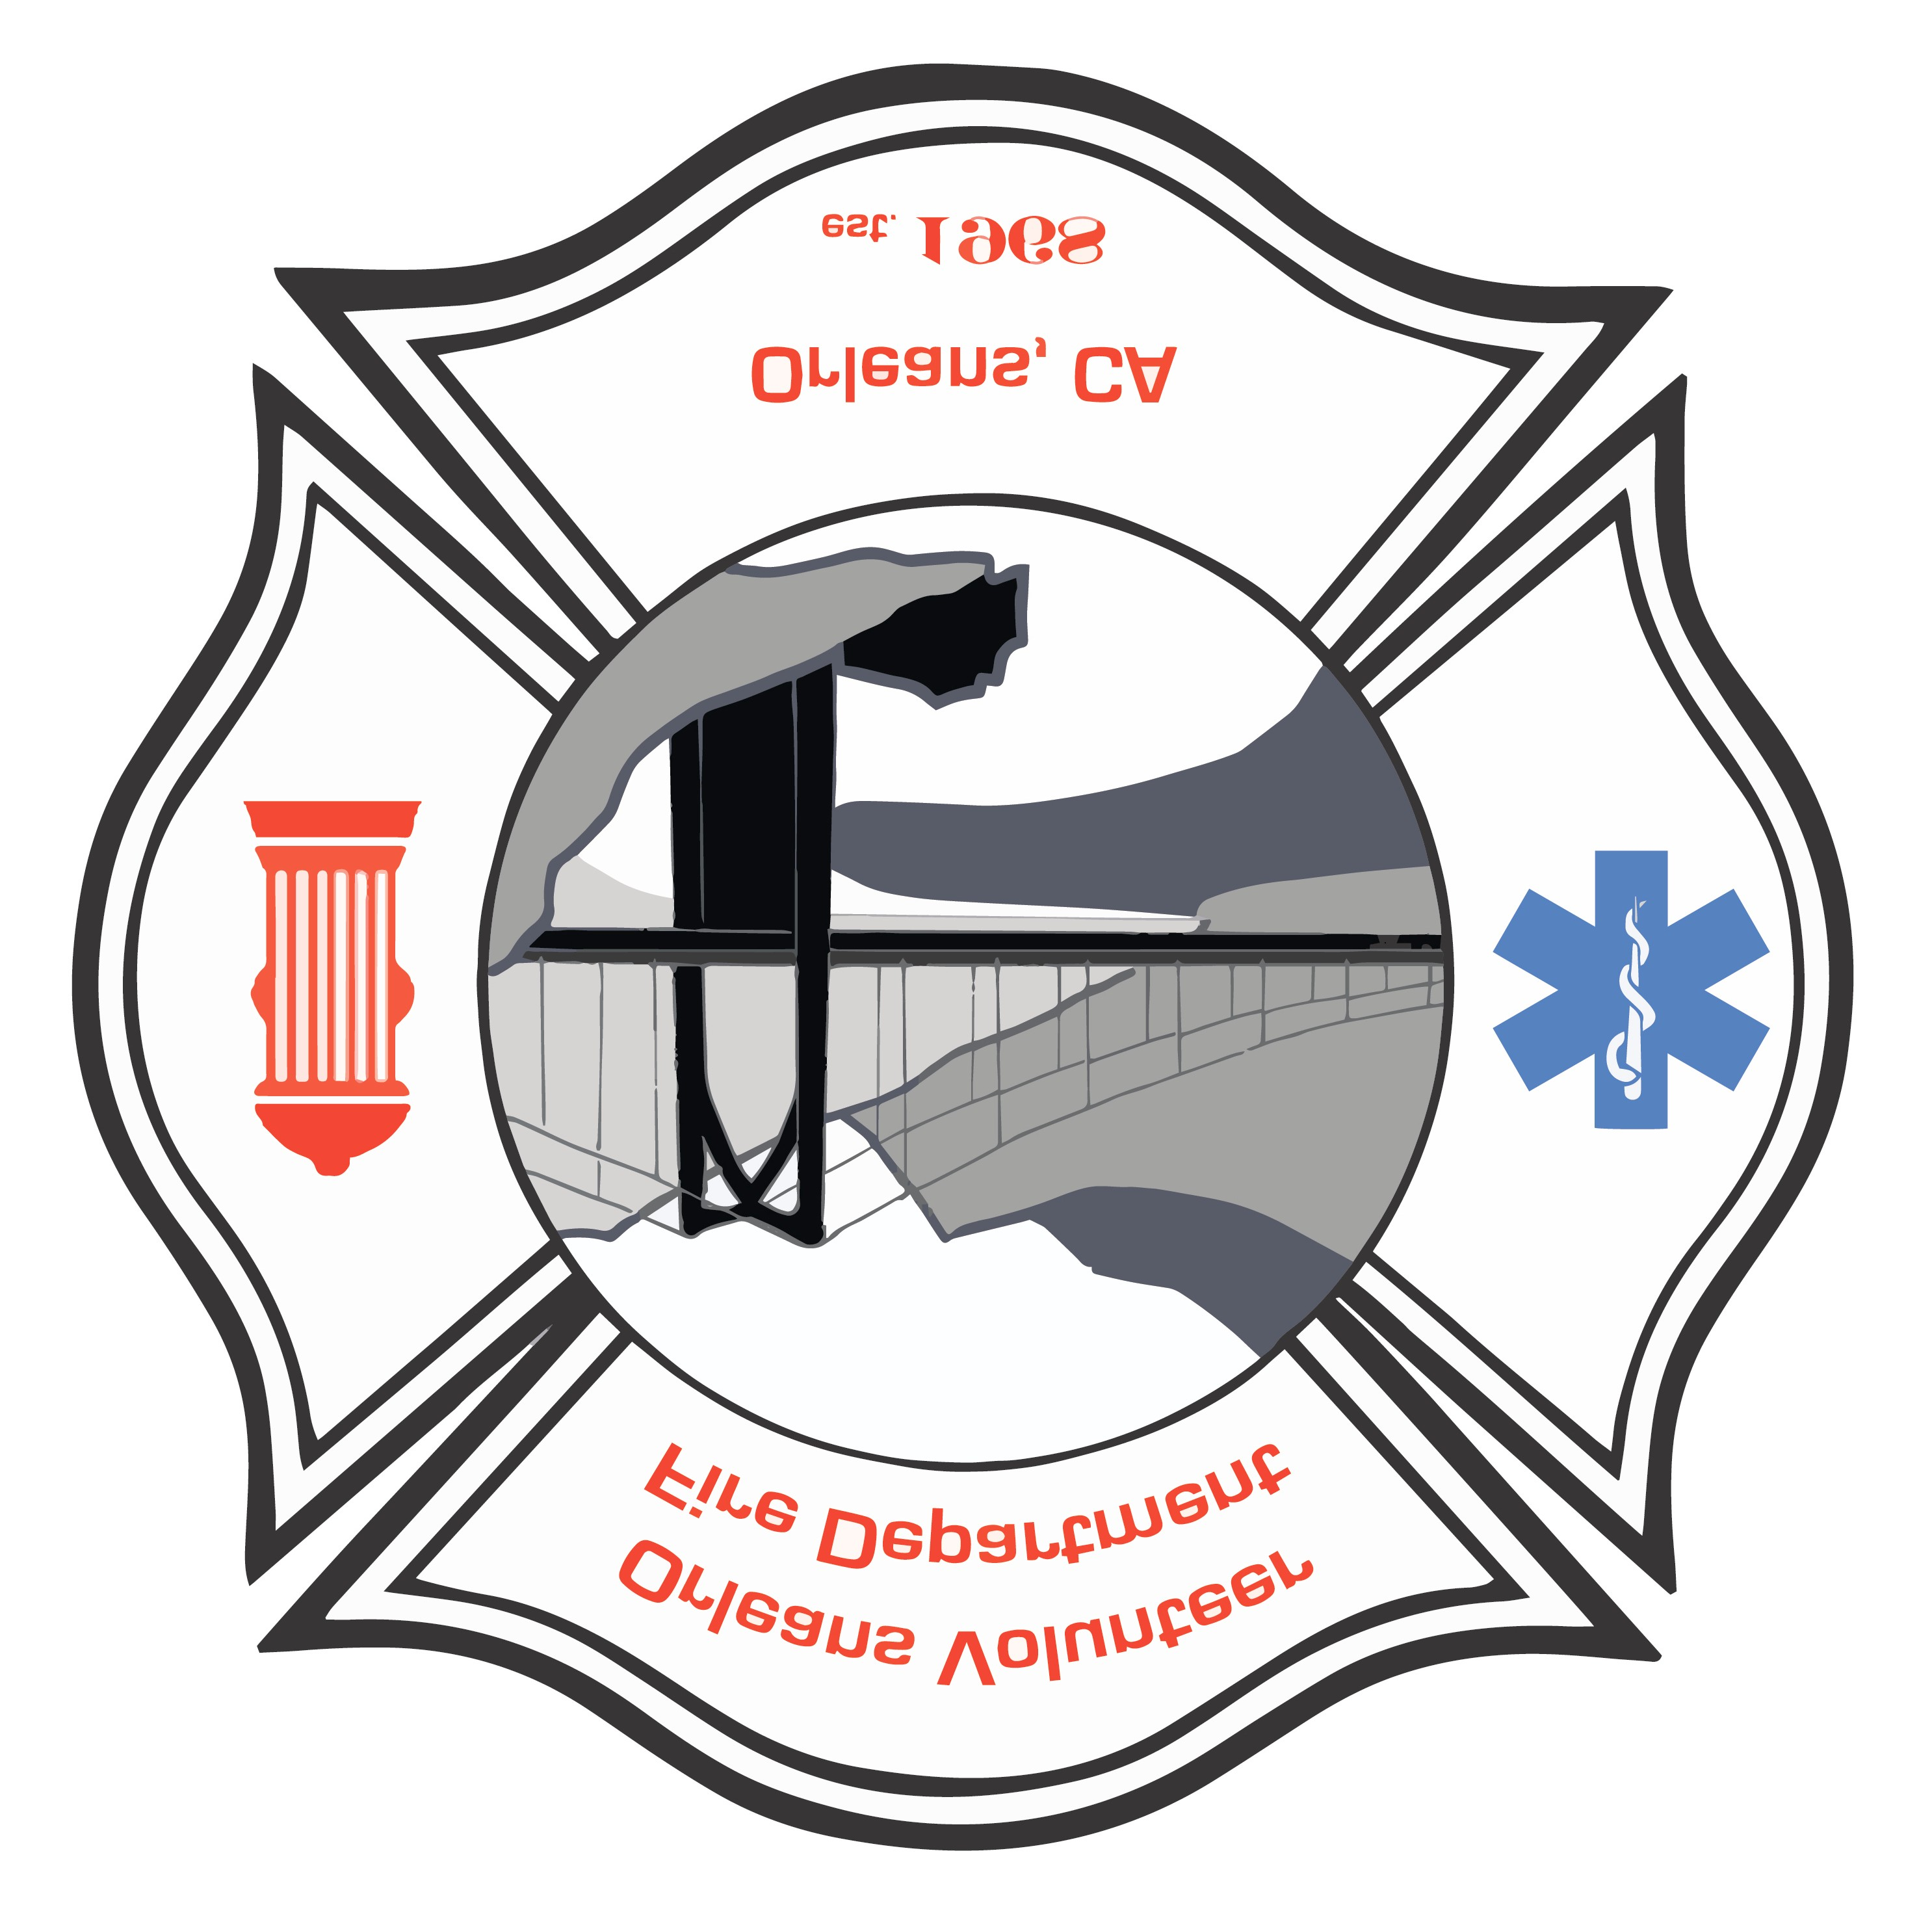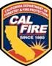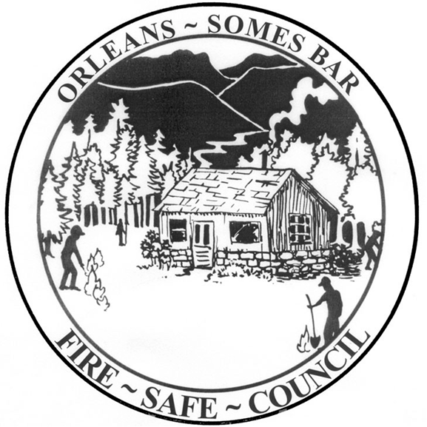

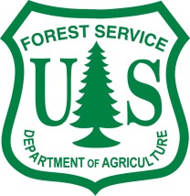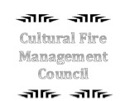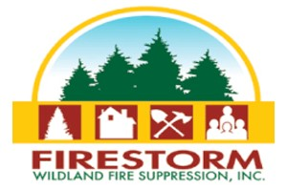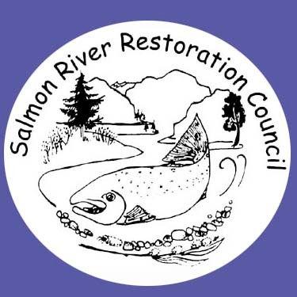

Training Announcement
2107 Klamath River Prescribed Fire Training Exchange (TREX)
Orleans, CA October 2 – October 15, 2017
Objectives: Provide participants and communities along the Klamath River with experience and training on how to plan and implement controlled burns, protect communities from wildfires, and prepare for managing wildfires for resource benefits.
Target Participants: This training is designed to integrate a diverse group of fire practitioners with varying degrees of knowledge and experience. Participants include interested individuals, tribal members, local contractors, federal and state firefighters, volunteer firefighters, non-profit organizations, university students, county/regional regulators and out-of-region and international guests and fire workers.
Description: The training is organized using a Type 3 Incident Management Team. Participants will serve in qualified and trainee positions in Operations, Logistics, Planning, and Finance and as members of the Command and General Staff. Operations participants will be on a burn team and will assist with preparing, scouting, briefing, igniting, holding, mop-up, and patrol on numerous controlled burns in the area. We will also complete pre- and post-fire monitoring, train with equipment, practice fireline leadership skills, and learn about local fire ecology and fire management. There will be field trips to past TREX burns, areas burned in recent wildfires and presentations from local tribal members and other community members, scientists, land managers, and practitioners.
Non-refundable Fee (due no later than September 16, 2017): If selected, a $300 registration fee is required from participants; university students must pay a $100 registration fee. Scholarships/paid positions may be available for qualifying local participants - contact Will Harling (will@mkwc.org) for more information. ** See attached map defining the “local area”.
Requirements:
All participants’ qualifications must be current. Prior to TREX, these trainings are available now online for anyone who needs them. Must have completed NWCG courses S-130 Blended and S-190, https://www.nwcg.gov/ as well as,
FEMA IS-100b https://training.fema.gov/is/courseoverview.aspx?code=IS-100.b and
FEMA IS-700a https://training.fema.gov/is/courseoverview.aspx?code=IS-700.a
- Participants should complete an arduous pack test before arriving. A moderate pack test is acceptable if coming as a TNC volunteer and serving in an RXCM (prescribed fire crewmember). A pack test and practice shelter deployment training will be provided on Oct. 1, if needed. For more information:http://www.fs.fed.us/fire/safety/wct/2002/pack_test_info_sheet.pdf.
- All participants must have insurance (e.g., workers’ comp, health or travel insurance) to cover any injury they may sustain during the training exchange.
- Participants should come with all appropriate Personal Protective Equipment (PPE), including fireline-approved boots (all leather work boots, 8-inches tall, non-slip soles and no steel toe), a New Generation Fire Shelter, a hard hat, Nomex clothing, all leather gloves, eye protection, a headlamp, and canteens for drinking water. For individuals who do not have PPE, it will be available for rent for $50 at the beginning of the event. Local participants can secure PPE with a $50 refundable deposit. Participants should also come prepared to camp (sleeping bag, pad, tent, etc.)
Meals & Travel: Meals and lodging will be provided during the training. Participants are responsible for their own travel to and from Orleans, CA and should arrive NO LATER THAN Monday (10/2). Burn Bosses, Burn Boss trainees, and the Incident Management Team must arrive 10am Saturday morning (9/30). We encourage you to stay for the full assignment, but we understand you may have special circumstances and can only apply for the first or second week (non-refundable fee still applies). Although all applications are appreciated, priority will be given to applicants staying for the full TREX.

To Apply: Complete the 2017 Klamath River TREX Application available at https://goo.gl/forms/bwcnLrEdQRcUdHmX2 no later than Aug 15, 2017. If no internet access, contact David Medford (530) 627-3446 ext. 3018. Thank you!

